**Hester, Joy (b. Elsternwick, Victoria, 31 August, 1920-1960)**

Hester was a Australian artist best known for her brush and ink drawings. These images, frequently of love, loss and despair, were produced quickly, containing spontaneous responses to the trials and tribulations of life. Hester’s working method was usually to sit on the floor, sometimes in social occasions, and rapidly draw. Her work expressed emotional states, even a kind of existential isolation and a sense of vulnerability as metaphors for the human condition. Hester’s drawings employed simple fluid lines, capturing the essence of an emotional state expressed bodily, especially in faces. She focused on the smallest moments, often mundane, yet intimate, and which reveal intense inner states, psychological insights, and especially focused on the relationships between men and women and ‘the contradictions of love’. She also often exhibited her poetry with her drawings. Influenced by the work of Picasso, Surrealism and German Expressionism, she associated with the so-called Angry Penguins group (including Albert Tucker, Sidney Nolan and Arthur Boyd) and was close friends with patrons John, and particularly Sunday, Reed.

The daughter of an alcoholic banker, who died when she was 12, Joy’s mother was domineering and they often argued. After attending St Michael’s Church of England Girls Grammar School (1933-35), Hester studied commercial art at Brighton Technical College (1936) and at National Gallery of Victoria School, (1937-38). She was a founding member of the Contemporary Art Society (1938). After 18 months she left art school, finding the course too conservative. In 1938 she ran away from home to live with Albert Tucker who she married in 1941. They had a son before separating in 1947, around the same time she was diagnosed with Hodgkins Disease. She then lived with Guy Gray Smith, had two more children, divorced from Tucker in 1959 and married Gray Smith later the same year. Sunday Reed continued to provide her with personal and financial support.

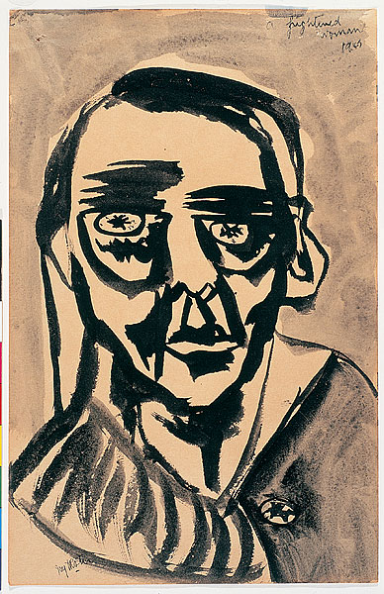

Joy Hester*, A Frightened Woman,* 1945, brush and ink, 31 x 20 cm, National Gallery of Australia. Accession No. 2001.67. Copyright held by VISCOPY Ltd, Sydney

In 1945 she saw early documentary film footage of Auschwitz and Ravensbruck concentration camps and began to do drawings of the Holocaust. At first these were sketches based on images in the film footage and then later she shifted to simply emphasise the eyes. For example, in *A Frightened Woman*, 1945, she used a few simple lines to express the harrowing experience now firmly embedded in this woman’s soul. The work *From an Incredible Night Dream*, (c.1946-47) from her well-known *Lovers* series (a major focus of her work from the late 1940s), shows a naked woman, head and neck agonisingly straining backwards, with her eye literally protruding from her face - a feature that reappeared in later works.

Hester’s work was largely ignored during her lifetime, and rediscovered by feminist scholars in the 1970s and 1980s. Many art historians consider her marginalisation as due to her choice of medium (ink and brush) given that greater salability of paintings at the time. She only held three solo show during her lifetime (in 1950, 1953, 1956) and her works sold only rarely. Following her death in 1960, there was a significant exhibition in 1963 at Georges Gallery, Melbourne, but nothing again until the 1980s.

**References and further reading::**

---- (1975) *Australian Women Artists: 1840-1940*, Melbourne: Ewing and George Paton Galleries, +Uni Melbourne

Burke, Janine. (1983) *Joy Hester*, Elwood: Greenhouse.

Gellatly, Kelly.(2001) *Leave No Space for Yearning: the art of Joy Hester*, Buleen: Heide Museum of Modern Art.

Hart , Deborah. (2004) *Joy Hester and Friends*, Canberra: National Gallery of Australia in association with Craftsman House.

Keon, Michael (1993) *Joy Hester: An unsettling world*, Melbourne: Malakoff Fine Art Press.

Jager, Claire (writer and director). (1995) *The Good Looker*, Omar Khayam Film– documentary film, 57 mins, 20 secs. Australian Screen (ASO), National Film and Sound Archive, NFSA title number: 308208. 3 clips available at <http://aso.gov.au/titles/documentaries/good-looker/>